1. Add Image to Canvas and admin stretches the image across the canvas, Lock aspect ratio of the image to prevent the user from distorting shape

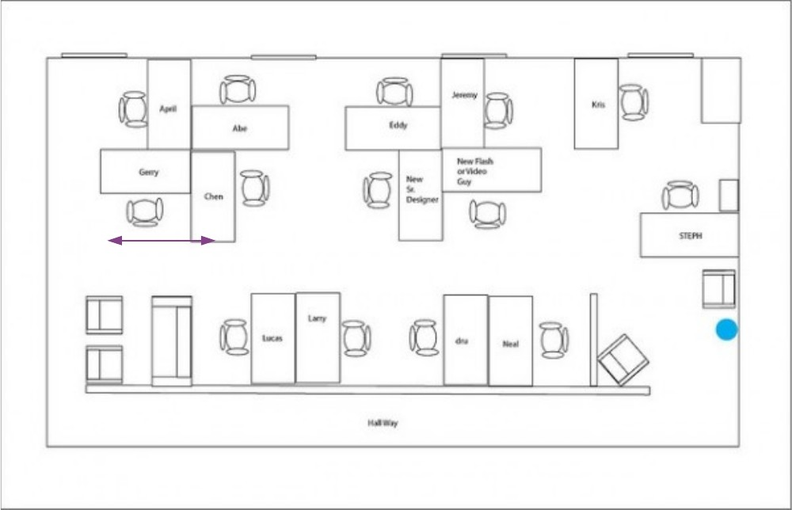

Set Canvas Scale

1. Image stretched fully across the canvas

Set Canvas Scale

1. User clicks on “Set Canvas Scale” button

Set Canvas Scale

4 . Disable “Set Canvas Scale” button and pop up modal

Set Canvas Scale

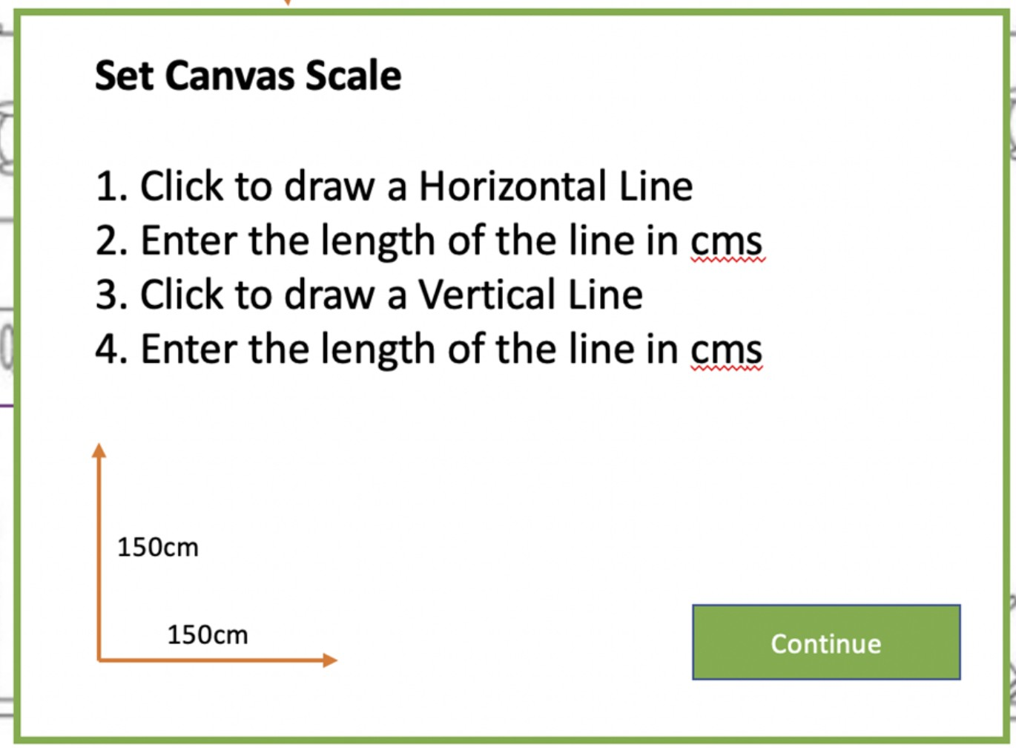

* 1. Admin draws a Verticle line, prevent user from drawing a Horizontal line

Set Canvas Scale



* 1. Popup an editable box to allow them to enter the length of the line drawn in cms, only accept 10cm to 200cms

Set Canvas Scale

150

* 1. Admin draws a Horizontal line, prevent user from drawing a vertical line

Set Canvas Scale

150

1. Popup an editable box to allow them to enter the length of the line drawn in cms, only accept 10cm to 200cms

Set Canvas Scale

150

175

1. Popup modal saying that the scaling is set!

150

175

Set Canvas Scale

|  |  |  |
| --- | --- | --- |
| Horizontal and Vertical scaling is now set!  This will be used later to aid COVID aware space | | |
| management | OK |  |

1. Enable the “Set Canvas scale” button again Enable “Set safe distance” Button

Set safe distance

Set Canvas Scale

1. Admin clicks on “Set safe distance” button, popup “Set safe your safe” modal

Set social distance

Set your safe distance!

Our system will warn you visually when two objects are closer than this limit

Safe distance

cm

OK

200

Set safe distance

Set Canvas Scale



1. Admin adds 4 seats. Determine dynamically what circles are outside the “Safe Distance” Put Red outlines around outside of circles that are all less than the safe distance

Set safe distance

Set Canvas Scale

Click to add object

1



3 4

2